SENSORS

Two types of sensors are commonly used:

• Exteroceptive Sensors: Those which help in sensing the environment, i.e., external to the robot. Example: LiDAR, Camera, Ultrasonic Sensor, Radar.

• Proprioceptive Sensors: Those which help in sensing/measuring the state of the "ego robot," i.e., the robot itself. Example: Encoders, IMU.

Perception, in simple words, is what the sensors see (perceive) from the environment. Sensors can see a person walking (dynamic object) or a painting on the wall (static object or Landmark). These observations are used to build a map of the environment. The static objects (or landmarks) are a part of the global map, where as dynamic objects are used by the local planner to plan a path around them by estimating the motion of the dynamic objects.

A variety of sensors have been used in order to try to solve the SLAM problem. The type of exteroceptive sensors can be categorized based on the range of sensors, or based on the type of data. Based on the sensors’ range there are short range sensors like ultrasonic sensor, and long range sensors LiDAR and Camera. Based on the type of data, there are sensors which provide color (RGB) images, Depth Images, 2D point cloud, 3D point cloud for the perception and mapping. For localization, proprioceptive sensors for measuring the odometry of the moving platform include encoders, Inertial Measurement Unit (IMU), GPS. Received signal strength from beacons is also used to localize a robot in the map. The beacons act as landmarks used to estimate the pose of the robot.

1) Kinect

a)

The Kinect is an RGB-D camera, where the ’D’ stands for Depth. It is a composite device which has become an important 3D measuring device [cite 1]. Developed by Microsoft as an add-on for their gaming platform console XBox-360, used for recording hand gestures of the user (gamer), the device has gained popularity in robotics research as a readily available depth camera.

As shown in Fig. 3.2, the device comprises of a regular color (RGB) camera, and an infrared (IR) camera paired with an IR projector which is used for measuring depth. Some of the intrinsic properties of the RGB camera are mentioned below:

Focal Length: 2.9 mm.
Field of View (FOV): 63x50 (Horizontal x Vertical) degrees.
Pixel Size: 2.8 µm.
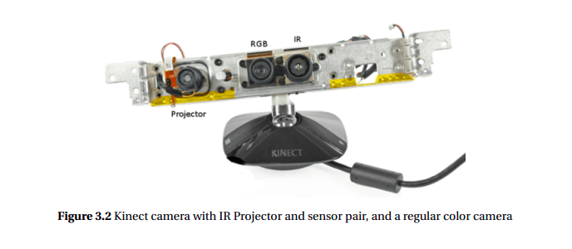
Max Resolution: 1280x1024 pixels

2) LiDAR

a)

A LiDAR (Light Detection And Ranging) is a device which, similar to a SONAR or RADAR, is used to map surroundings. The only difference is that instead of Sound or Radio waves, Light (Laser) is used. The LiDAR used in this research was a SLAMTEC RPLIDAR-A3 which is a 360◦ Laser Range Scanner, shown in Fig. 3.3. It is a unidirectional Laser (projector and sensor pair) rotating about a vertical axis giving an omnidirectional sense of measurement. The ability to rotate helps map the complete surrounding in range of the sensor. The sensor parameters are as follows:

Range: 25 m.
Samples per second: 16000.

The sensor provides a polar coordinates (angle, distance) of the measured points. These polar coordinates are converted into Cartesian (x, y) coordinates to be used for mapping, localization, and path planning.

b) RPLIDAR that shown in Figure 18 is a low-cost LIDAR sensor suitable for indoor robotic SLAM applications. It provides a 360-degree scan field, 5.5hz/10hz rotating frequency with guaranteed 8-meter ranger distance. RPLIDAR is the ideal sensor in cost sensitive areas like robots consumer and hardware hobbyist. Besides, ROS (Robot Operating System) is a popular software library for robotics programming. It is free, opensource, and used by robotics researchers and companies around the world [15]. In this project, Lidar scan surroundings and provide information to the SLAM algorithm for map unknown environments.

3) Encoders

a)

The encoders used are 2-phase rotary encoders with 600 pulses per revolution. Single phase encoders are useful to measure the rotational speed of the motor, while 2-phase encoders also tell the direction of rotation. The two channels, A and B, generate pulses in coordination such that the direction is determined by whether pulse A is leading pulse B, or vice versa. Having a sense of direction of rotation helps us determine the direction of wheelchair’s motion.
The encoders are interfaced with an Arduino using interrupts. For every pulse generated by the encoders, an interrupt is raised and a pulse count is increased in the interrupt service routine. The number of pulses, along with the direction, is used to calculate the angular velocity of the motor and hence the wheel which is further translated to linear velocity. This will be derived further in the Kinematics section of this chapter

4) Inertial Measurement Unit (IMU)

a)

IMU or Inertial Measurement Unit have become an essential part of the robotics industry. The aviation industry has been using IMUs for many years for measuring the orientation (roll, pitch, yaw) of airplanes, the linear acceleration, and direction wrt. EarthâA˘Zs´ magnetic North. This sensor is used for inertial navigation technology in both airplanes and also in recently in some high end ground vehicles. An Inertial Navigation System (INS) provides the dead reckoning of a vehicle’s position, velocity, and orientation. An IMU is used for vehicle motion control when its GPS satellite communication is lost for a certain period of time. For robot hobbyists, IMU is available in many variants including 6-DOF, 9-DOF, 10-DOF, and 11-DOF categories. Generally, IMU consists of 3 DOFs for accelerometer (x, y, and z axes), 3 DOFs for gyroscope which measures orientation wrt. axes x, y, z - pitch, roll, and yaw respectively. Further, 3 DOFs are for magnetometer, which is essentially a compass measuring the Earth’s magnetic field and calculating the heading of the sensor (or the vehicle). Many manufacturers also provide barometer or pressure sensor, and a temperature sensor as extra degrees of freedom. The barometer is used to calculate the altitude, from sea level. The IMU we used is a 9-DOF Bosch BNO055 sensor. Following are the properties of the sensor taken from the datasheet available at [Sen]:

Absolute Orientation: Euler Vector, 100Hz
Absolute Orientation: Quaternion, 100Hz
Angular Velocity Vector: 100Hz, 3-axis rad/s
Acceleration Vector: 100Hz, 3-axis in m/s 2
Magnetic Field Strength Vector: 20Hz, micro Tesla (µT)
Linear Acceleration Vector: 100Hz, 3-axis m/s 2
Gravity Vector: 100Hz, 3-axis in m/s 2

